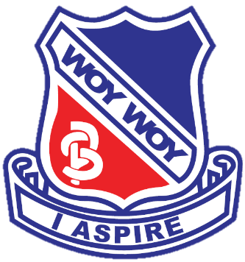
WOY WOY PUBLIC SCHOOL

KINDERGARTEN

2020

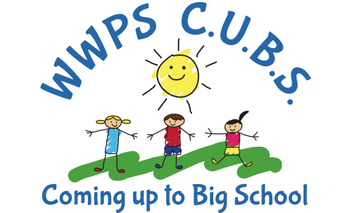
OPEN CLASSROOMS

- Thursday 4th July
10:00 – 10:30am
- Tuesday 20th August
10:00 – 11:00am

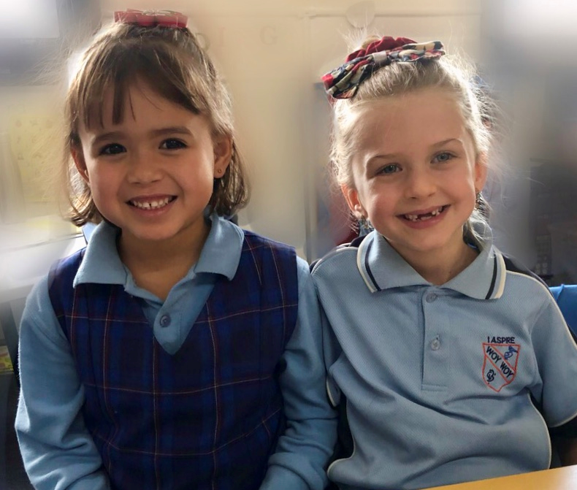
PARENT INFORMATION
SESSIONS

- Wednesday 24th July
3:00 – 4:00pm
- Wednesday 31st July
3:00 – 4:00pm
- Tuesday 3rd September
6:00-7:00pm

PRINCIPAL’S TOURS
Woy Woy Public School
Park and Blackwall Roads
Woy Woy NSW 2256
Ph: (02) 4341 3555
E-mail: woywoy-p.school@det.nsw.edu.au

- Friday 28th June
9:00 – 9:30am
- Tuesday 6th August
9:00 – 9:30am

“We challenge and support all students to achieve their personal best”

