Offering a range of quality educational programs

* *Quality literacy programs including L3 and FoR*
* *Quality numeracy programs including TEN*
* *Early Years Learning Framework*
* *Values Education program years K-6*
* *Stephanie Alexander Kitchen, Garden Program Years 3-6*
* *Music, Dance and Drama Performances*
* *Reading Recovery*
* *Early Intervention*
* *Disability Program classes*
* *Interactive classrooms*
* *Positive Behaviour for Learning (PBL) System for student wellbeing*

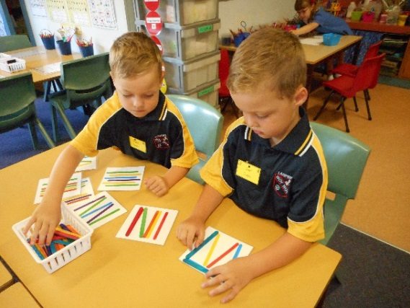

***Woy Woy Public School’s mission is to provide a warm, caring, secure place where students and their efforts are valued by a committed staff and an actively supportive community.***

**I Aspire is our motto. Respect is our job**

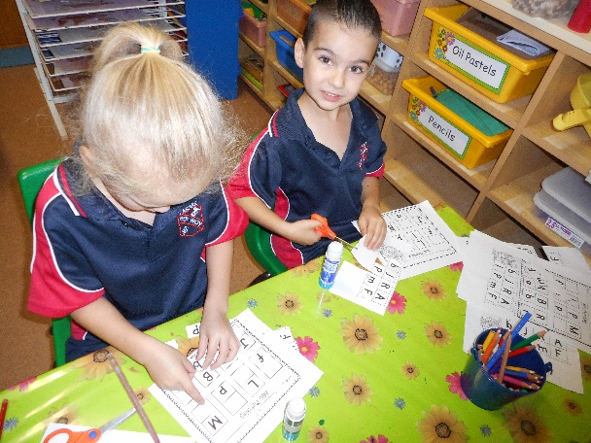

Woy Woy Public School

*Park and Blackwall Rds*

*Woy Woy NSW 2256*

*Phone 4341 3555 ; Fax 4344 3927*

*Email :* [*woywoy-p.school@det.nsw.edu.au*](mailto:woywoy-p.school@det.nsw.edu.au)

***“We challenge and support all students to achieve their personal best”***



**Woy Woy Public School**

**2016**

***Is your child starting Kindergarten?***

***Is your child starting***

***school in 2017?***



*Our school is enrolling Kindergarten students for the 2017 now.*

*We offer a caring and supportive transition program for your child run by experienced and dedicated staff.*

*Enrolments can be made at the school office during school hours.*

***Mon-Fri: 8.50 am – 2:50 pm***

*Please provide the following information to our office staff*

*upon enrolment.*

* *Immunisation Certificate*
* *Birth Certificate*
* *Completed Enrolment form*

***Evening information session***

***for parents and families.***

***Tuesday 16th August, 2016***

***(School Hall 6:00 – 7:00 pm)***

*Your child is invited to attend the following Kindergarten Transition Program sessions:*

***Session 1:***

***Wednesday 26th October, 2016***

***9:00 am – 10:30 am***

***(Parents presentation in hall)***

***Session 2:***

***Wednesday 2nd November, 2016***

***9:00 am – 10:30 am***

***Session 3:***

***Wednesday 9th November, 2016***

***9:00 am- 12:00 noon***

***Session 4:***

***Wednesday 16th November, 2016***

***9:00am – 2:00 pm***

*Dates for the commencement of the school year:*

***Friday 27th January, 2017***

***(staff)***

***Monday 30th January, 2017***

***(Years 1-6 students)***

***Tuesday 31st January, 2017 (Kindergarten students)***

*Details for the first day of school will be discussed at the parent information evening on*

***Tuesday 16th August, 2016***

*Please feel free to ask our staff any questions that will help make your child’s first day of school a success.*

*If your child has any special needs for starting school, please do not hesitate to contact the office to discuss these with the Principal or Early Stage One Assistant Principal.*

