***WWPS Scope and Sequence of PBL Targeted Behaviours***

***Term 2***

*For the first two weeks of the new school year, certain classroom and playground behaviours need to be explained and taught to students as a matter of priority. These are specified below:*

***Week 1***

Lesson Detail:

Register/Evaluation:

***Week 2***

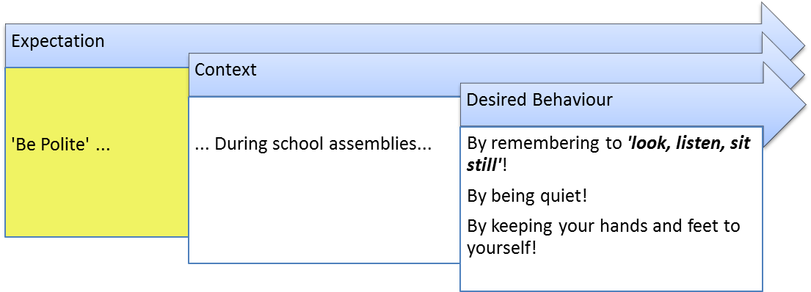

Lesson Detail:

Register/Evaluation:

***Week 3***

Lesson Detail:

Register/Evaluation:

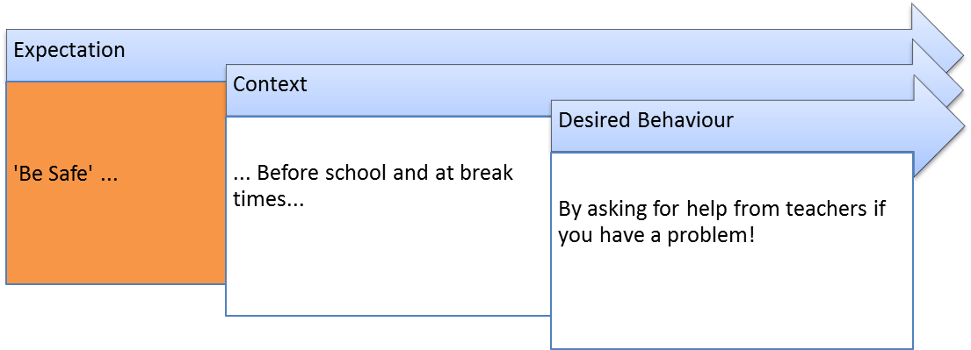

***Week 4***

Lesson Detail:

Register/Evaluation:

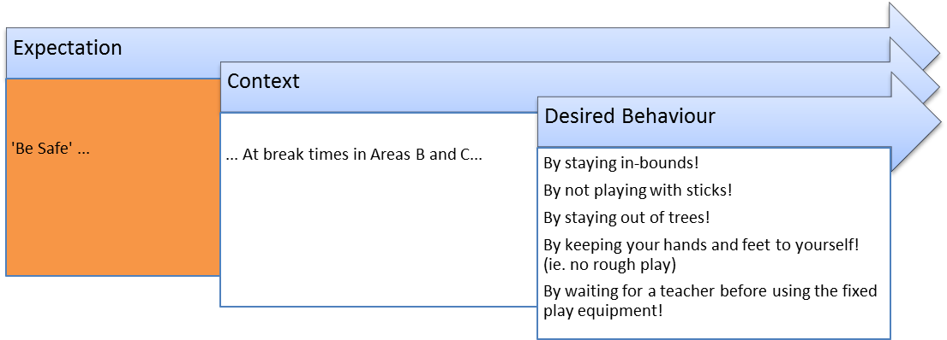

***Week 5***

Lesson Detail:

Register/Evaluation:

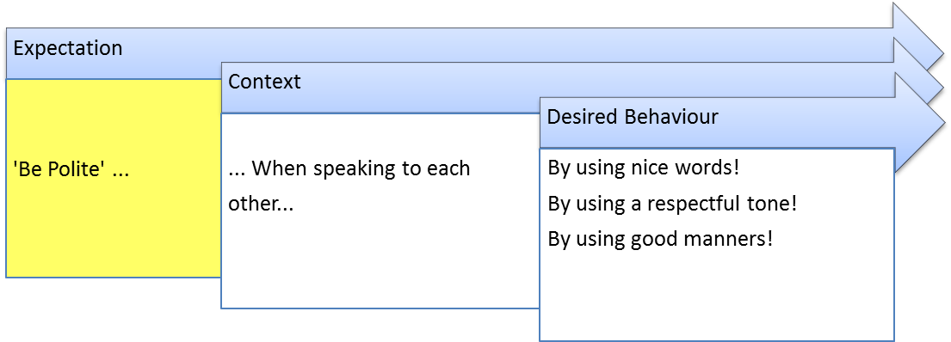

***Week 6***

Lesson Detail:

Register/Evaluation:

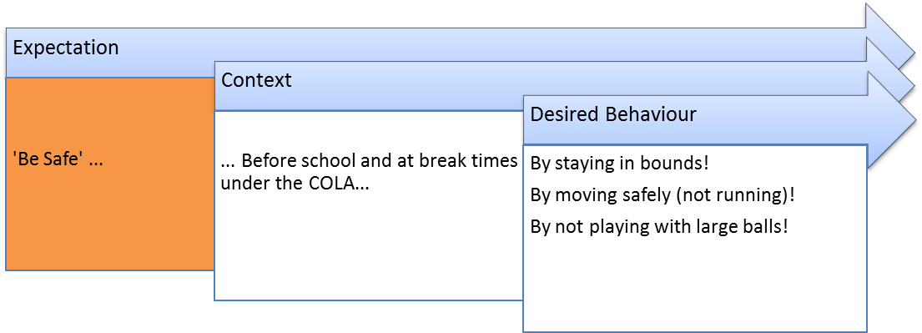

***Week 7***

Lesson Detail:

Register/Evaluation:

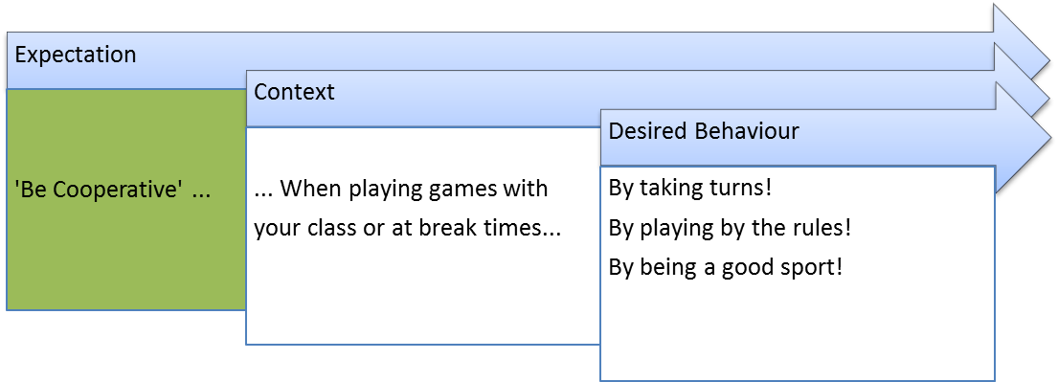

***Week 8***

Lesson Detail:

Register/Evaluation:

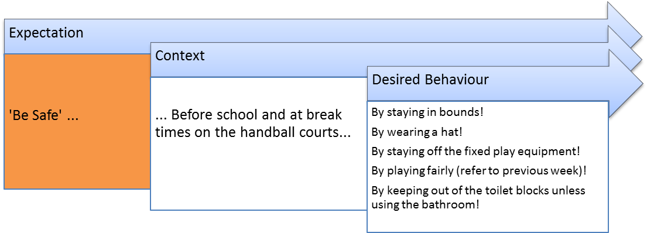

***Week 9***

Lesson Detail:

Register/Evaluation:

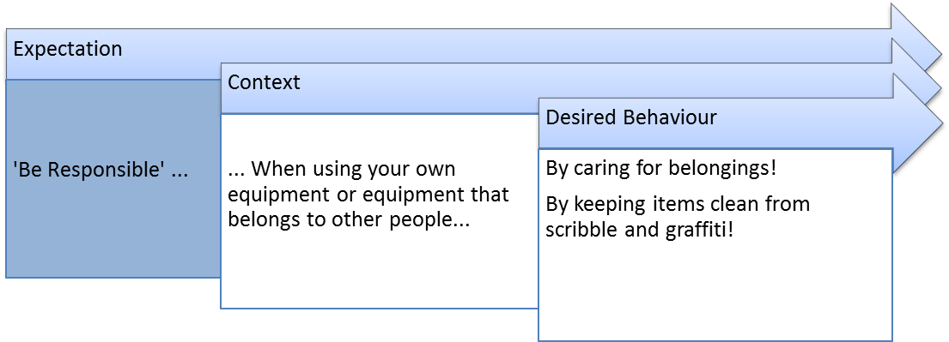

***Week 10***

Lesson Detail:

Register/Evaluation:

