***WWPS Scope and Sequence of PBL Targeted Behaviours***

***Term 4***

***Week 1***

Lesson Detail:

Register/Evaluation:

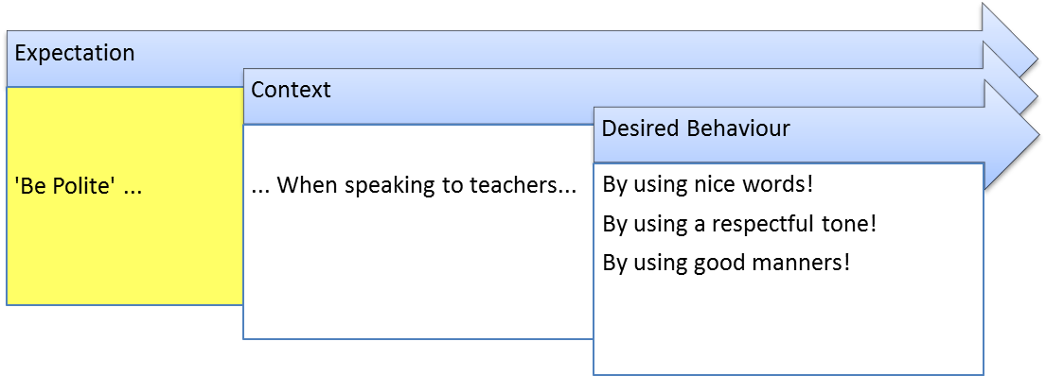

***Week 2***

Lesson Detail:

Register/Evaluation:

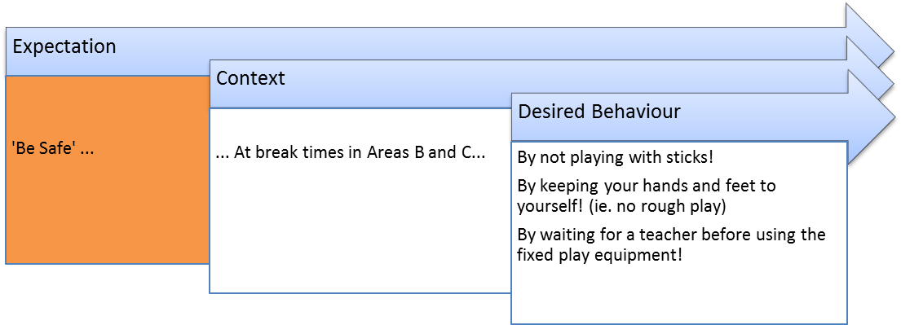

***Week 3***

Lesson Detail:

Register/Evaluation:

Lesson Detail:

Register/Evaluation:

***Week 4***

Lesson Detail:

Register/Evaluation:

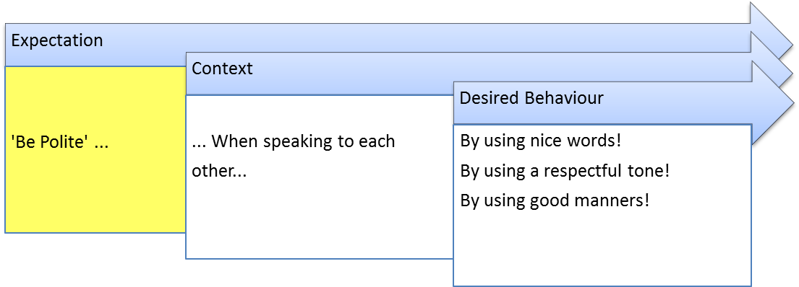

***Week 5***

Lesson Detail:

Register/Evaluation:

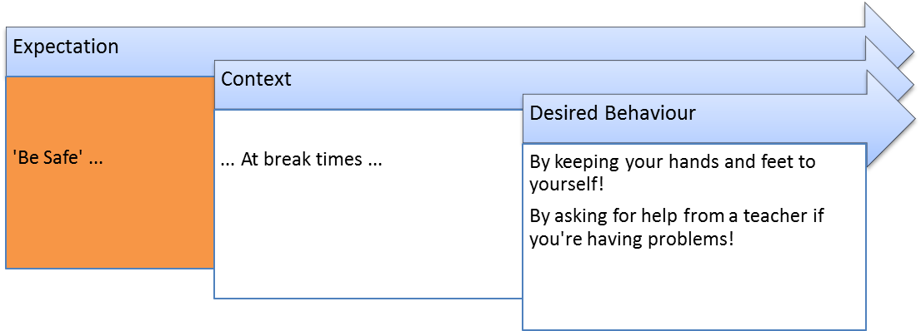

***Week 6***

Lesson Detail:

Register/Evaluation:

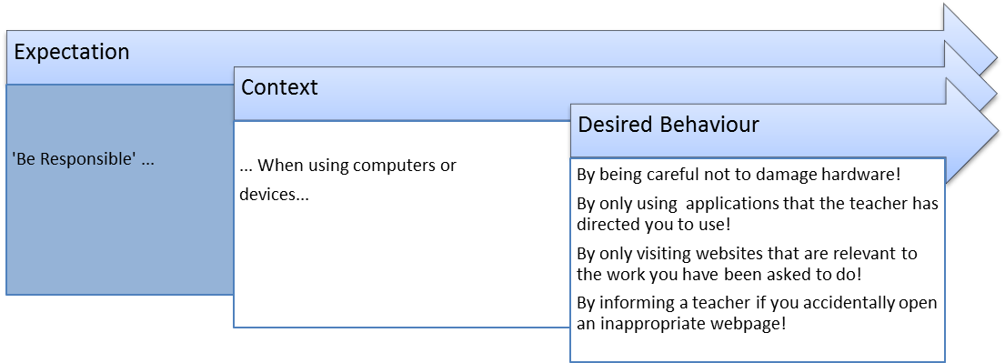

***Week 7***

Lesson Detail:

Register/Evaluation:

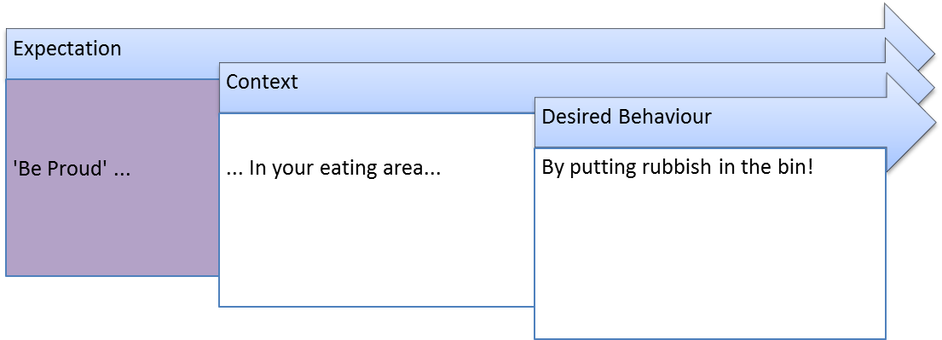

***Week 8***

Lesson Detail:

Register/Evaluation:

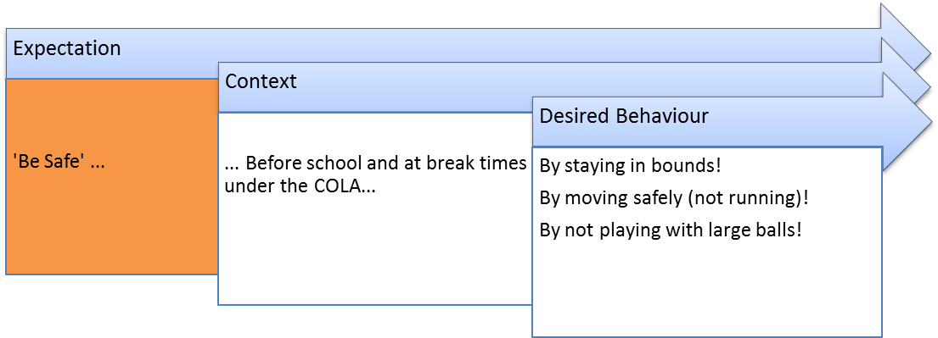

***Week 9***

Lesson Detail:

Register/Evaluation:

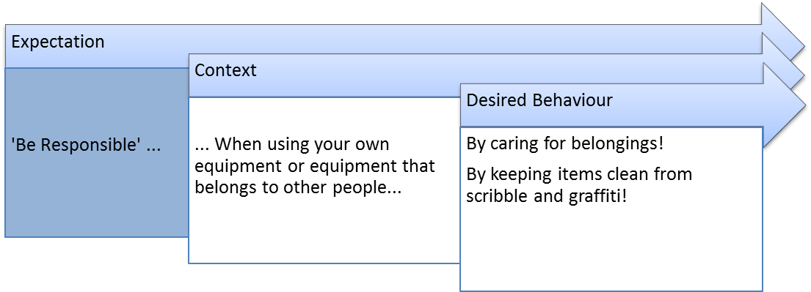

***Week 10***

Lesson Detail:

Register/Evaluation:

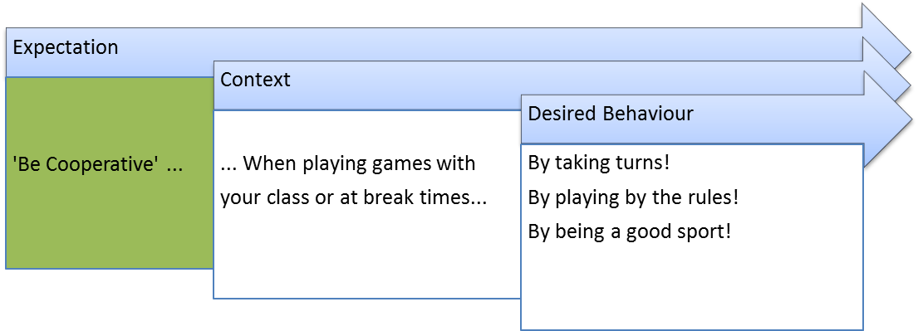

***Week 11***

Lesson Detail:

Register/Evaluation:

